For Immediate Release

Office of the Māori Climate Commissioner: WRONG-HEADED STRATEGY ON TREE PLANTING EVIDENT IN GOVT’S PAN PAC DECISION

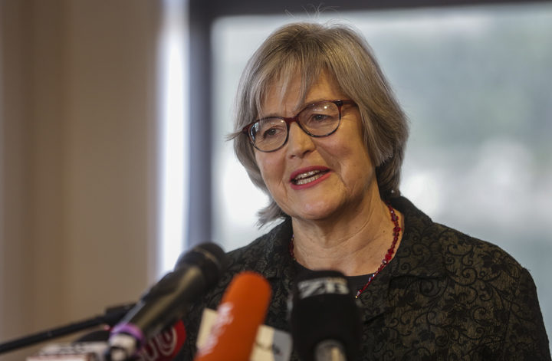

The Government’s decision to give a foreign-owned forestry company unfettered access to New Zealand land highlights the hypocrisy of their approach to forest management says Māori Climate Commissioner Donna Awatere Huata.

Land Information Minister Eugenie Sage has just signed off a deal to allow Japanese-owned Pan Pac Forest Products special approval to buy up to 22,000ha of local land without the scrutiny of the Overseas Investment Office.

“The Government – including the Greens – are allowing foreign-owned companies to buy up local land to convert into forestry in order to ship the wood off to feed international demand, while leaving all the attendant problems like slash, damage to roading infrastructure and degradation of land and waterways behind,” says Commissioner Awatere Huata.

“Meanwhile, they are not even allowing local Māori the right to determine how they can best use the marginal land they’ve been able to retain.”

“What’s more, Pan Pac themselves have said the decision will allow them to better compete against local investors to buy land here.”

Commissioner Awatere Huata says if the Government is serious about addressing the climate crisis it should be doing more to encourage local owners to plant permanent carbon forests in the appropriate places, rather than given foreign investors carte blanche to buy up local land to turn into rotational forests with few carbon benefits.

“The Government – in this case led by Greens MP Eugenie Sage – is sending all the wrong messages to the world about how New Zealand is responding to its responsibilities under the Paris Agreement.”

“While foreign-owned slash and burn foresters are being welcomed with open arms, the permanent carbon farmers are being tied up in red tape.”

“For example, most major iwi forestry interests have asked the Government to allow a change in the ETS setting to enable them to use offset planting to make the best use of the margin land in their possession. If the Government can’t deliver this for local iwi, which will encourage more permanent regenerating forests on the right land, and yet they can overwrite the OIO to welcome international buyers, then there is something seriously wrong with their approach to the climate crisis.”

For further details, please contact:
Donna Awatere Huata
Māori Climate Commissioner
022 070 0996

