For Immediate Release

Māori Climate Commissioner: "National's Environment Discussion Document thinks it can buy it's way out of climate change consequences"

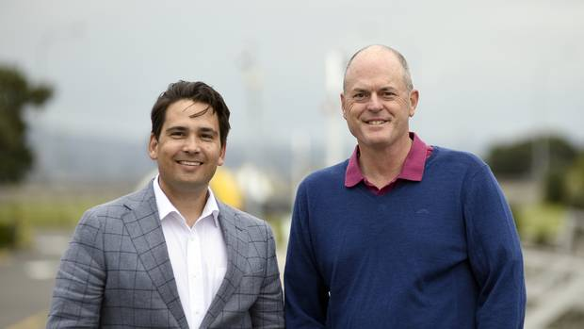

Māori Climate Commissioner, Donna Awatere Huata, says the latest Environment Discussion Document by National misses the enormity and threat of climate change.

"National are still in denial about the true scale and reality climate change threatens our economy and environment with a discussion document that sounds like the same tired ideas".

"In parts, National sound like they can buy themselves out of climate change."

Boutique travel parks in our national parks, electric car subsidies, litter campaigns, tech fixes we are no where close to fixing, gene editing pest controls and proclaiming our natural reserves are 'birth rights' are all very well and good, but they don't set out a radical enough plan to combat climate change".

"This discussion document is an abdication of leadership by National and it can only be the first sentence in a long debate if the Party are serious about protecting our environment."

"We already have a Government who seem to be only paying lip service to climate change, we don't need an Opposition to do that as well."

For all media enquiries please contact:
Donna Awatere Huata
Māori Climate Commissioner
021 196 4441

